K. R. Mangalam University
School of Engineering & Technology
Computer Science fundamentals & career pathways
Assignment-2
Name: Nikhil Bhiduri
Roll No: 2501010128
Course: B.Tech CSE
Section: B

Introduction
Linux is a powerful and widely used operating system in both academic and industrial environments.Its flexibility, security, and scripting capabilities make it an essential skill for computer science and IT professionals. Here I have performed and recorded steps to install linux (distro - Ubuntu) on a virtual environment using VMware, and performed certain commands and tasks on it.

Installation
- Download Ubuntu ISO and VMWare Workstation from the following sites respectively:
  - https://ubuntu.com/
  - https://knowledge.broadcom.com/external/article/344595/downloading-and-installing-vmware-workst.html
- Install VMware and create a new virtual machine and run the Ubuntu ISO and install it. Configure the install location and virtual machine settings according to your PC’s specifications.

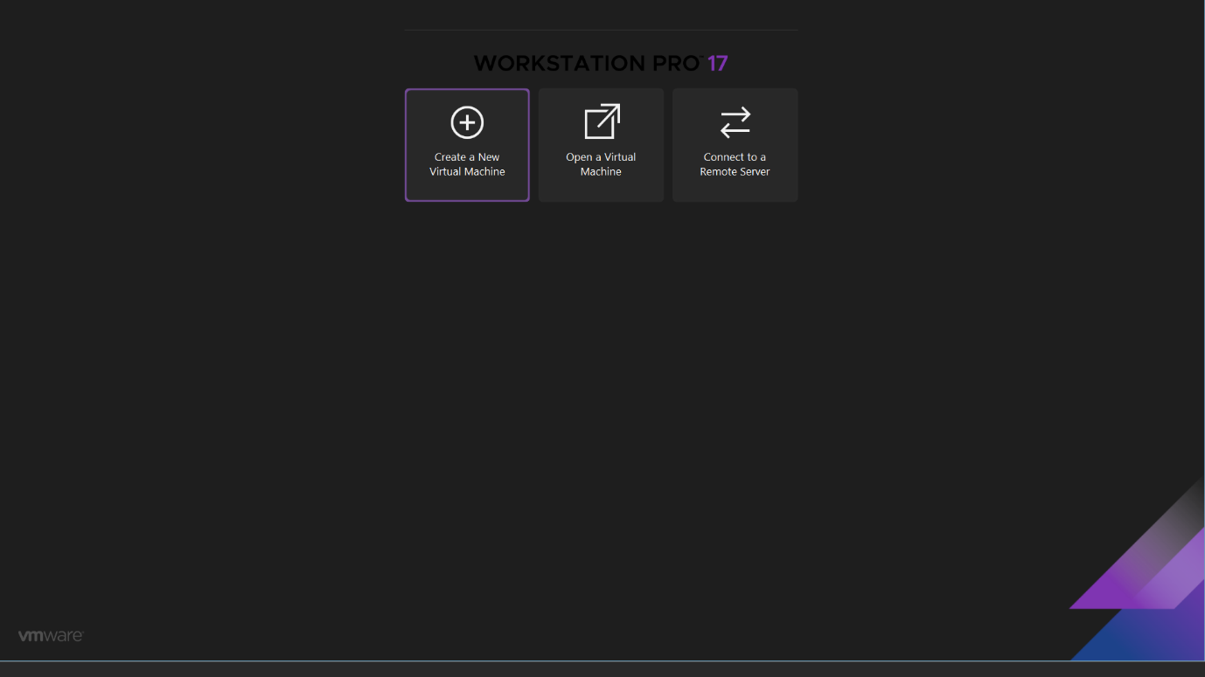
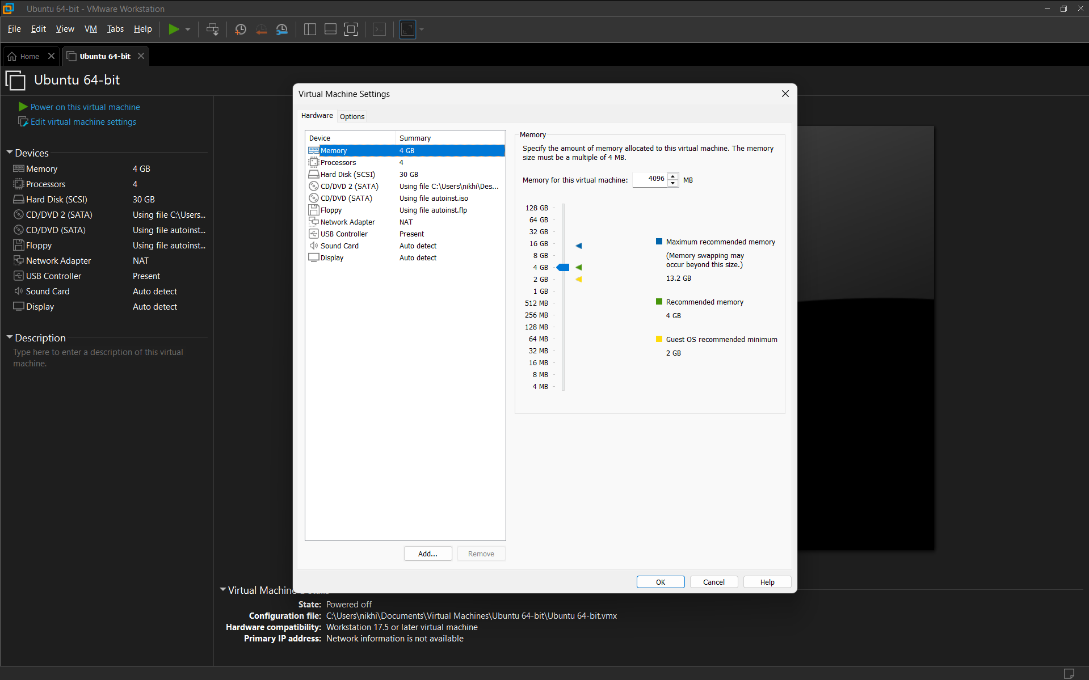
- Finalise installation and start the Virtual Machine.


Shell Command Implementation
- File Navigation
- ls
Shows a list of files and folders in the current directory.
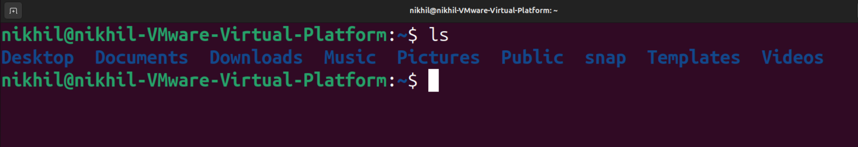
- ls -la
Show all files (including hidden ones) with detailed information.
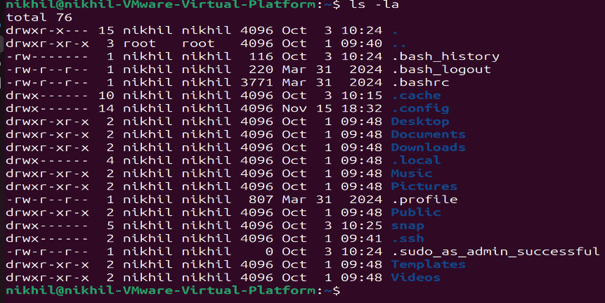
- cd /path
Change directory to any other specified directory.
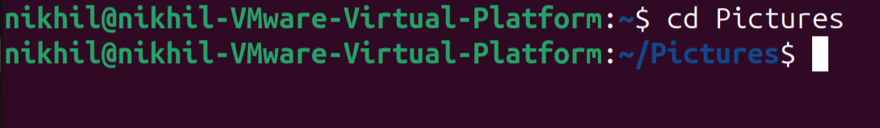
- cd ..
Display contents of directories in a tree-like hierarchy.
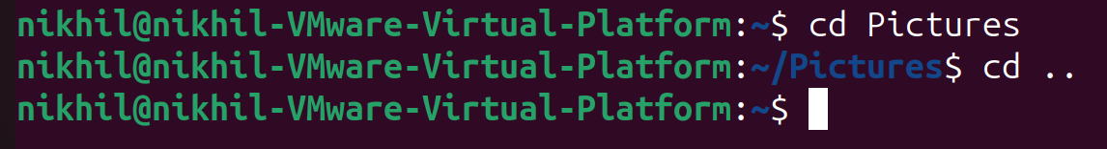

- pwd
Display current working directory (currently opened folder).
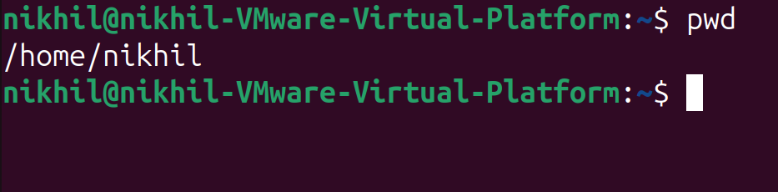

- File Management
- mkdir foldername
Create new folder with given name.
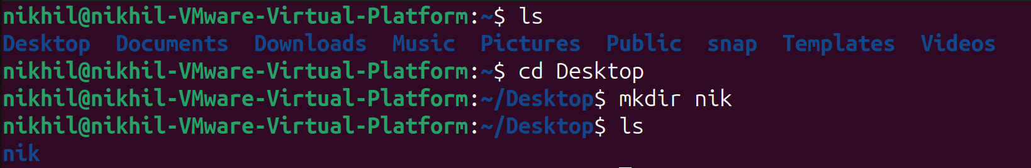
- rm filename
Delete file permanently.
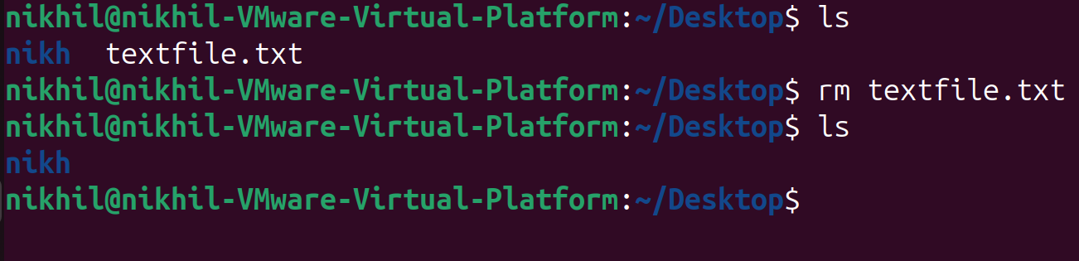
- rm -r foldername
Delete folder and all its included files recursively.
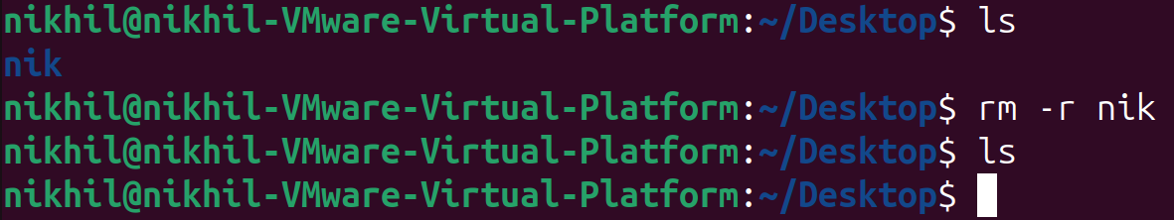
- cp filename/foldername(with -r)
Copies file or entire folder with its included files.
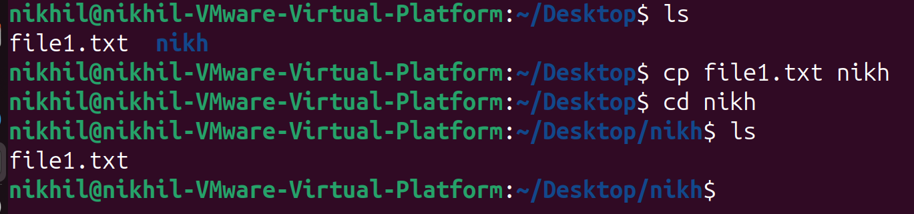
- mv oldname newname
Move or rename file/folder.
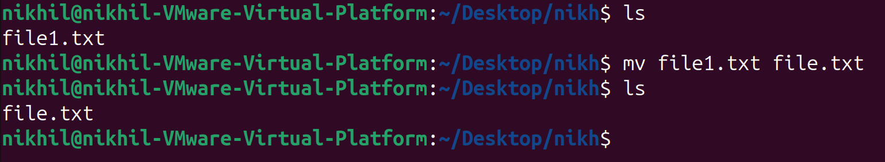
- Permissions Management
- Chmod
Changes file permissions for all types of owners.
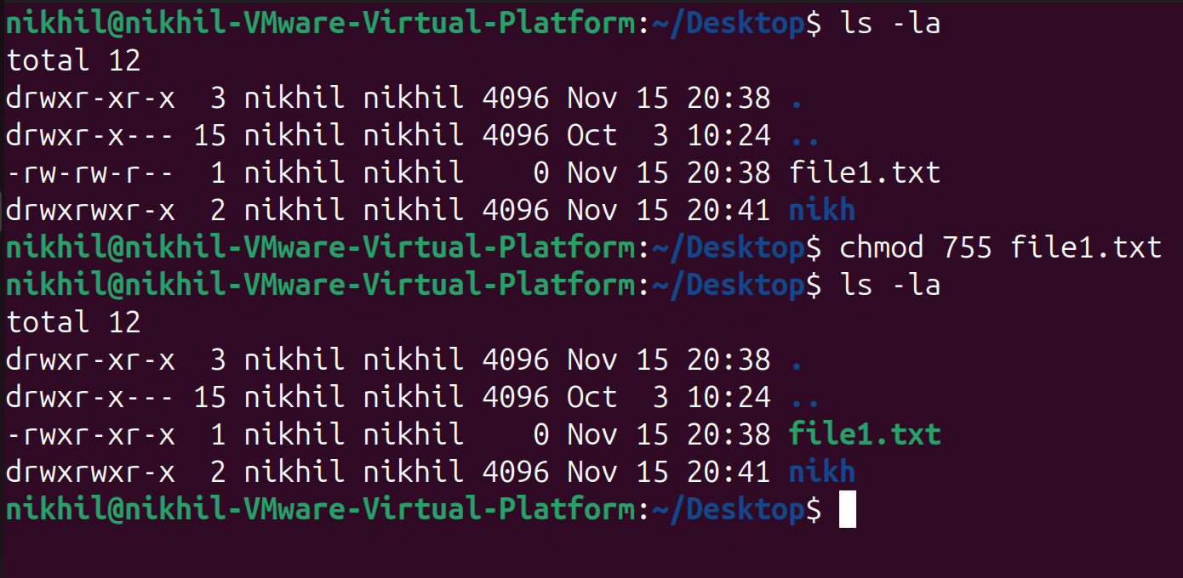

- Chown
Changes ownership of file.
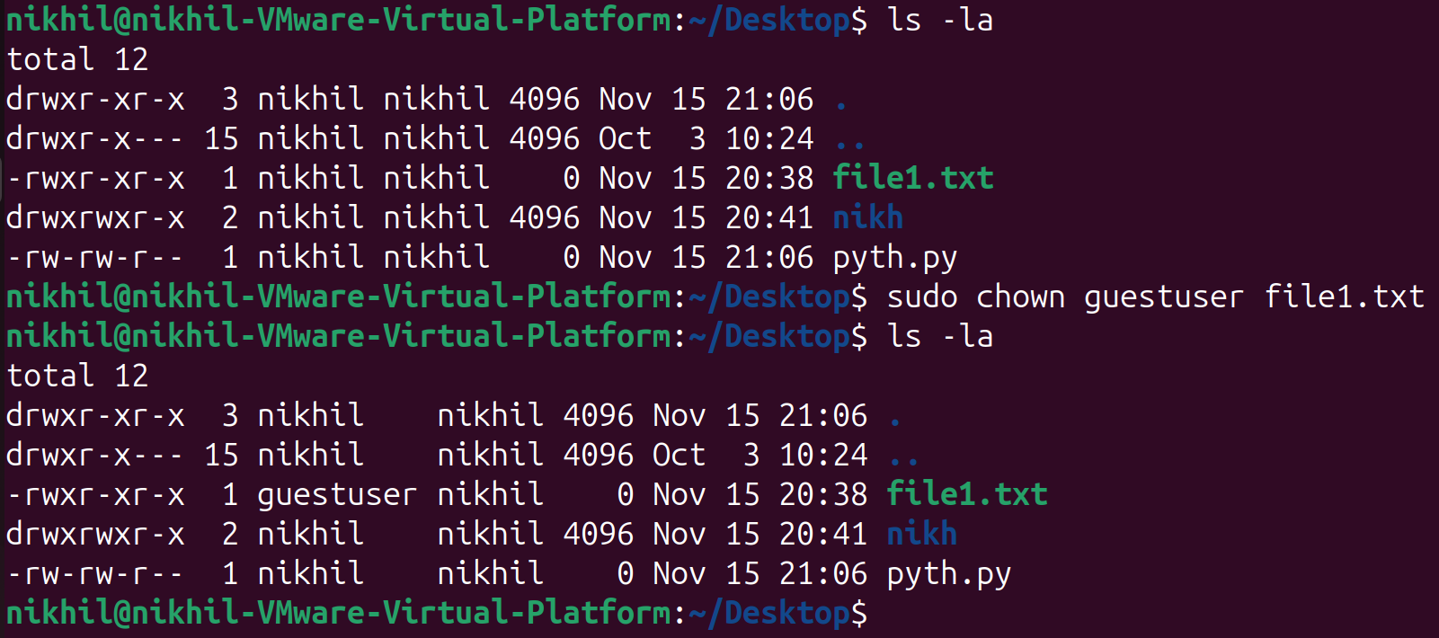
- System & Process Monitoring
- ps
List running process in your current session.
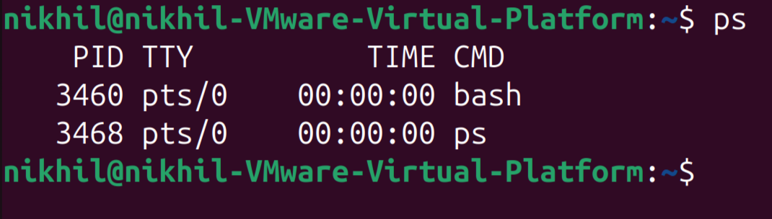
- top
Shows running processes and system usage in real-time.
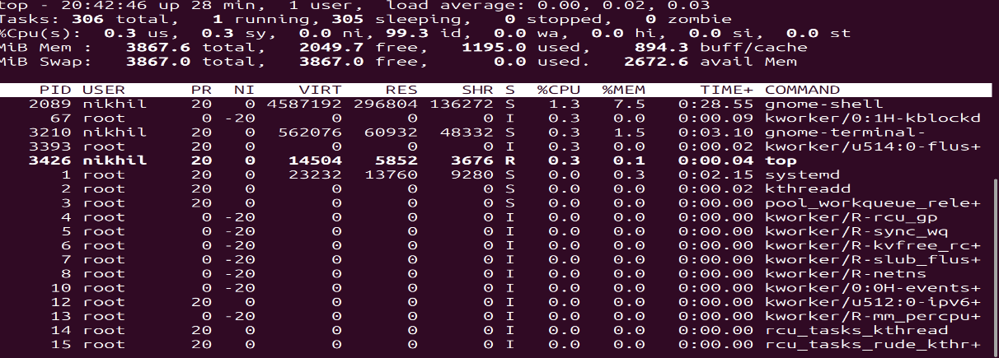
- Networking Tools
- ping
Tests internet connection and latency.
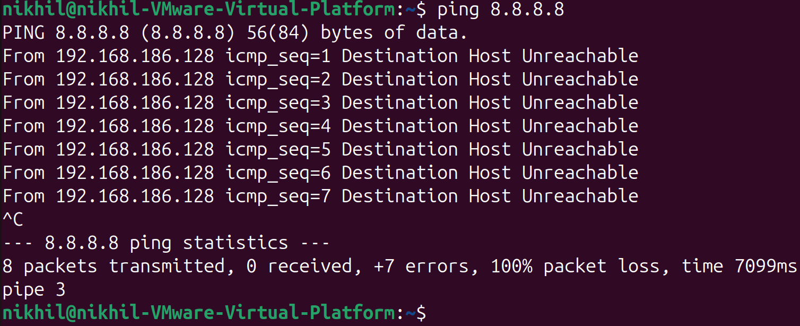
- Curl
Fetches or downloads website data from URLs.
- wget
Download files from the internet.
- Package Management
- sudo apt update
Refreshes list of available software packages.
- sudo apt upgrade
Installs the latest version of installed packages.

Shell Script Development
- Directory Backup
It takes a folder you choose and creates a backup copy of it, storing the backup inside a /backup folder in your home directory where each backup has a timestamp, so nothing gets overwritten. It checks for if you forgot to provide a directory also.
- CPU/Memory Tracking
- Automated Downloading

